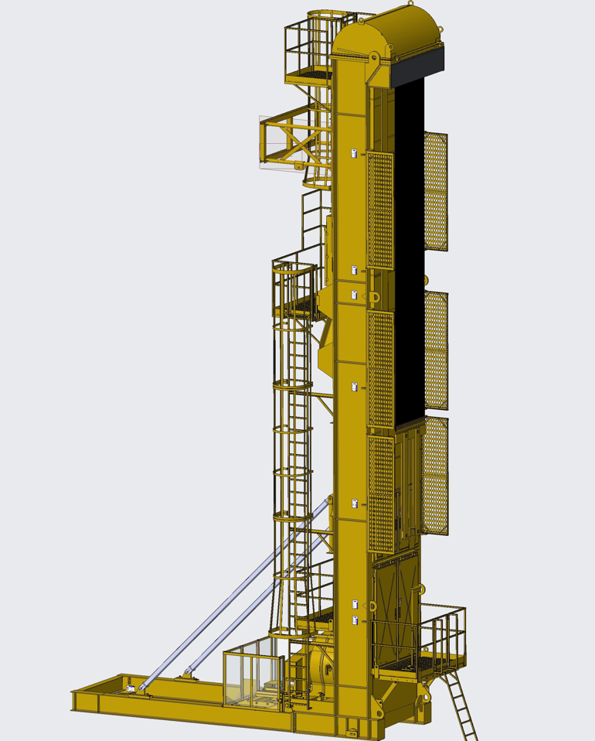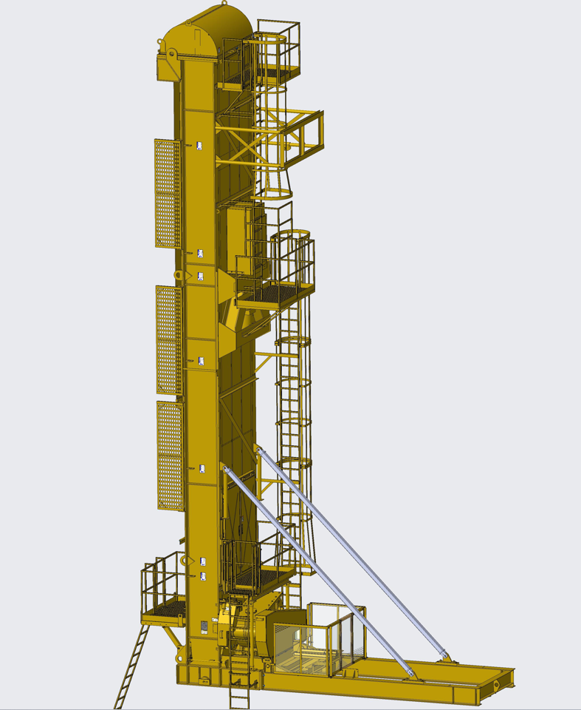

Outline Dimensions
A:Total unit height from bottom of base to top of hood
B:Distance from bottom of tower base to bottom of rod-hanger bar
C:Distance from bottom of base to top of front platform
D:Distance from well center to front of tower base
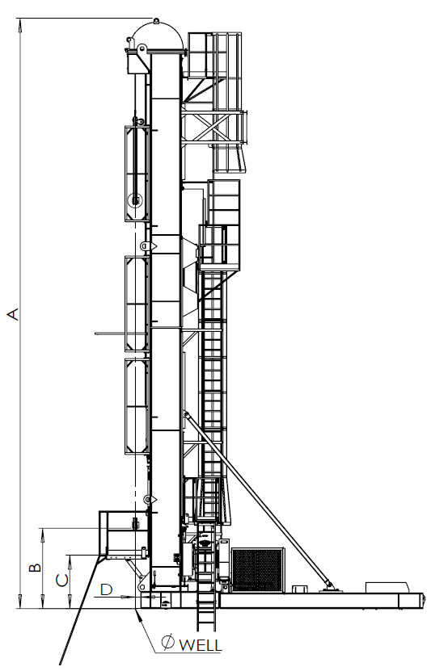

Model | A | B | C | D
320-360-291 | 477.53 in (12.13 m) | 73.27 in (1.86 m) | 49.88 in (1.27 m) | 5.38 in (0.14 m)
320-500-306 | 533.03 in (13.54 m) | 86.94 in (2.21 m) | 53.6 in (1.36 m) | 5.64 in (0.14 m)
350-500-306 | 533.03 in (13.54 m) | 86.94 in (2.21 m) | 53.6 in (1.36 m) | 5.64 in (0.14 m)
320-500-366 | 593.03 in (15.06 m) | 86.94 in (2.21 m) | 53.6 in (1.36 m) | 5.64 in (0.14 m)
350-500-366 | 593.03 in (15.06 m) | 86.94 in (2.21 m) | 53.6 in (1.36 m) | 5.64 in (0.14 m)
320-500-416 | 593.53 in (16.33 m) | 86.94 in (2.21 m) | 53.6 in (1.36 m) | 5.64 in (0.14 m)
350-500-416 | 593.53 in (16.33 m) | 86.94 in (2.21 m) | 53.6 in (1.36 m) | 5.64 in (0.14 m)

General Specifications
Model | 320-360-291 | 320-500-306 | 350-500-306
Reducer rating | 320000 in-lb | 320000 in-lb | 350000 in-lb
Structure rating | 36000 lbs | 50000 lbs | 50000 lbs
Stroke length | 291 in | 306 in | 306 in
Maximum pumping speed | 4.5 SPM | 4.3 SPM | 4.3 SPM
Minimum pumping speed | No minimum for short-term operation | No minimum for short-term operation | No minimum for short-term operation
Minimum counterbalance | 8,551 lb(3,878 kg) | 9,700 lb(4,400 kg) | 9,700 lb(4,400 kg)
Auxiliary counterbalance | 23,949 lb(10,863 kg) | 29,600 lb(13,426 kg) | 29,600 lb(13,426 kg)
Total ECB | 34,500 lb(15,649 kg) | 39,300 lb(17,826 kg) | 39,300 lb(17,826 kg)
Unit Dimensions LxWxH | 21.6x11.3x39.5 ft  (6.6x3.4x12.1 m) | 27.3x11.9x44.3 ft  (8.3x3.6x13.5 m) | 27.3x11.9x44.3 ft  (8.3x3.6x13.5 m)
Unit Shipping Size LxWxH | 39.7x8.3x10.2 ft  (12.1x2.6x2.9 m) | 44.5x8.7x10.2 ft  (13.6x2.6x3.1 m) | 44.5x8.7x10.2 ft  (13.6x2.6x3.1 m)
Unit Shipping Weight | 55,637 lb(25,237 kg) | 63,051 lb(28,600 kg) | 64,153 lb(29,100 kg)
Concrete Base Dimensions | 24x8.5x1 ft(7.3x2.6x0.3 m) | 24x8.5x1 ft(7.3x2.6x0.3 m) | 24x8.5x1 ft(7.3x2.6x0.3 m)
Concrete Base Weight | 29,000 lb(13,154 kg) | 29,000 lb(13,154 kg) | 29,000 lb(13,154 kg)
Concrete Nose Pad Dimensions | 60"x137.2" | 60"x137.2" | 60"x137.2"
Concrete Nose Pad Weight | 8,921 lb(4,046 kg) | 8,921 lb(4,046 kg) | 8,921 lb(4,046 kg)
Working Temperature | -40°F to 140°F (-20°C to 60°C) | -40°F to 140°F (-20°C to 60°C) | -40°F to 140°F (-20°C to 60°C)
Load Belt Dimensions | 0.44"x40"x381.75" | 0.44"x50"x406" | 0.44"x50"x406"
Load Belt Tensile Strength | 1,800N/mm | 1,800N/mm | 1,800N/mm
Automatic brake | YES | YES | YES
Hydraulic RollbackSystem | YES | YES | YES

Model | 320-500-366 | 350-500-366 | 320-500-416
Reducer rating | 320000 in-lb | 350000 in-lb | 320000 in-lb
Structure rating | 50000 lbs | 50000 lbs | 50000 lbs
Stroke length | 366 in | 366 in | 416 in
Maximum pumping speed | 3.7 SPM | 3.7 SPM | 3.2 SPM
Minimum pumping speed | No minimum for short-term operation | No minimum for short-term operation | No minimum for short-term operation
Minimum counterbalance | 9,700 lb(4,400 kg) | 9,700 lb(4,400 kg) | 9,700 lb(4,400 kg)
Auxiliary counterbalance | 29,600 lb(13,426 kg) | 29,600 lb(13,426 kg) | 29,600 lb(13,426 kg)
Total ECB | 39,300 lb(17,826 kg) | 39,300 lb(17,826 kg) | 39,300 lb(17,826 kg)
Unit Dimensions LxWxH | 27.3x11.9x49.3 ft  (8.3x3.6x15.1 m) | 27.3x11.9x49.3 ft  (8.3x3.6x15.1 m) | 29.4x11.9x53.5 ft  (8.9x3.6x16.3 m)
Unit Shipping Size LxWxH | 49.3x8.7x10.2 ft  (15.1x2.6x3.1 m) | 49.3x8.7x10.2 ft  (15.1x2.6x3.1 m) | 53.5x8.7x10.2 ft  (16.3x2.6x3.1 m)
Unit Shipping Weight | 65,090 lb(29,525 kg) | 66,193 lb(30,025 kg) | 68,353 lb(31,005 kg)
Concrete Base Dimensions | 24x8.5x1 ft(7.3x2.6x0.3 m) | 24x8.5x1 ft(7.3x2.6x0.3 m) | 24x8.5x1 ft(7.3x2.6x0.3 m)
Concrete Base Weight | 29,000 lb(13,154 kg) | 29,000 lb(13,154 kg) | 29,000 lb(13,154 kg)
Concrete Nose Pad Dimensions | 60"x137.2" | 60"x137.2" | 60"x137.2"
Concrete Nose Pad Weight | 8,921 lb(4,046 kg) | 8,921 lb(4,046 kg) | 8,921 lb(4,046 kg)
Working Temperature | -40°F to 140°F (-20°C to 60°C) | -40°F to 140°F (-20°C to 60°C) | -40°F to 140°F (-20°C to 60°C)
Load Belt Dimensions | 0.44"x50"x466" | 0.44"x50"x466" | 0.44"x50"x516"
Load Belt Tensile Strength | 1,800N/mm | 1,800N/mm | 1,800N/mm
Automatic brake | YES | YES | YES
Hydraulic RollbackSystem | YES | YES | YES

API Linkage Dimensions
Model | 350-500-416
Reducer rating | 350000 in-lb
Structure rating | 50000 lbs
Stroke length | 416 in
Maximum pumping speed | 3.2 SPM
Minimum pumping speed | No minimum for short-term operation
Minimum counterbalance | 9,700 lb(4,400 kg)
Auxiliary counterbalance | 29,600 lb(13,426 kg)
Total ECB | 39,300 lb(17,826 kg)
Unit Dimensions LxWxH | 29.4x11.9x53.5 ft  (8.9x3.6x16.3 m)
Unit Shipping Size LxWxH | 53.5x8.7x10.2 ft  (16.3x2.6x3.1 m)
Unit Shipping Weight | 69,455 lb(31,505 kg)
Concrete Base Dimensions | 24x8.5x1 ft(7.3x2.6x0.3 m)
Concrete Base Weight | 29,000 lb(13,154 kg)
Concrete Nose Pad Dimensions | 60"x137.2"
Concrete Nose Pad Weight | 8,921 lb(4,046 kg)
Working Temperature | -40°F to 140°F (-20°C to 60°C)
Load Belt Dimensions | 0.44"x50"x516"
Load Belt Tensile Strength | 1,800N/mm
Automatic brake | YES
Hydraulic RollbackSystem | YES

